Name: Noah Dunn

Instructor: Dr. Campbell

Class: CSE 551

Date: 2/19/2020

Assignment: cURL + Postman

With help from:  
Dr. Campbell

1.

curl -d '{"key":"WashItAllAway", "value":"Solved", "password":"password"}' -H "Content-Type: application/json" -X **PUT** -i <http://campbest.451.csi.miamioh.edu/cse451-campbest-web-public-2020/week2/week2-rest.php/api/v1/info>

2.

HTTP/1.1 200 OK

Date: Wed, 19 Feb 2020 23:17:29 GMT

Server: Apache/2.4.29 (Ubuntu)

Access-Control-Allow-Origin: *

Access-Control-Allow-Methods: GET,POST,PUSH,OPTIONS

Access-Control-Allow-Headers: Content-Type

Content-Length: 43

Content-Type: application/json

3.

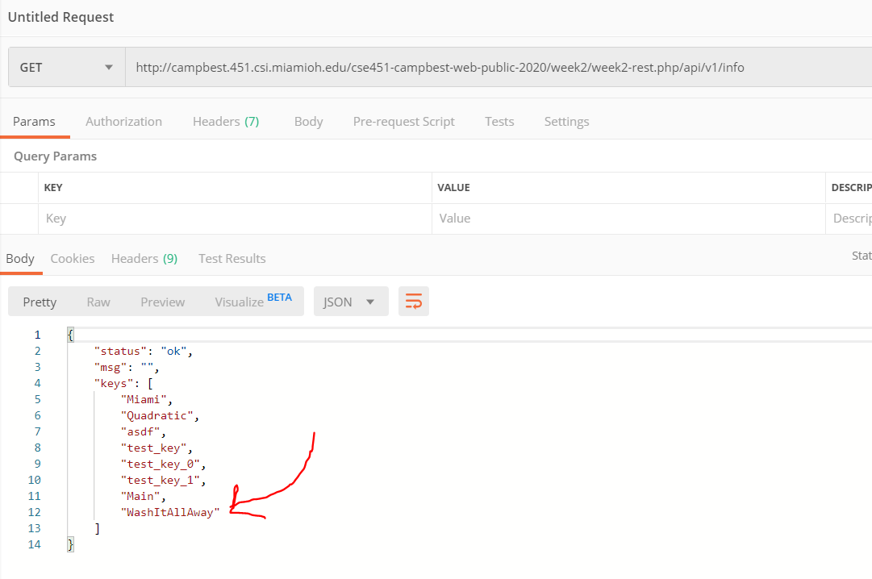

4.

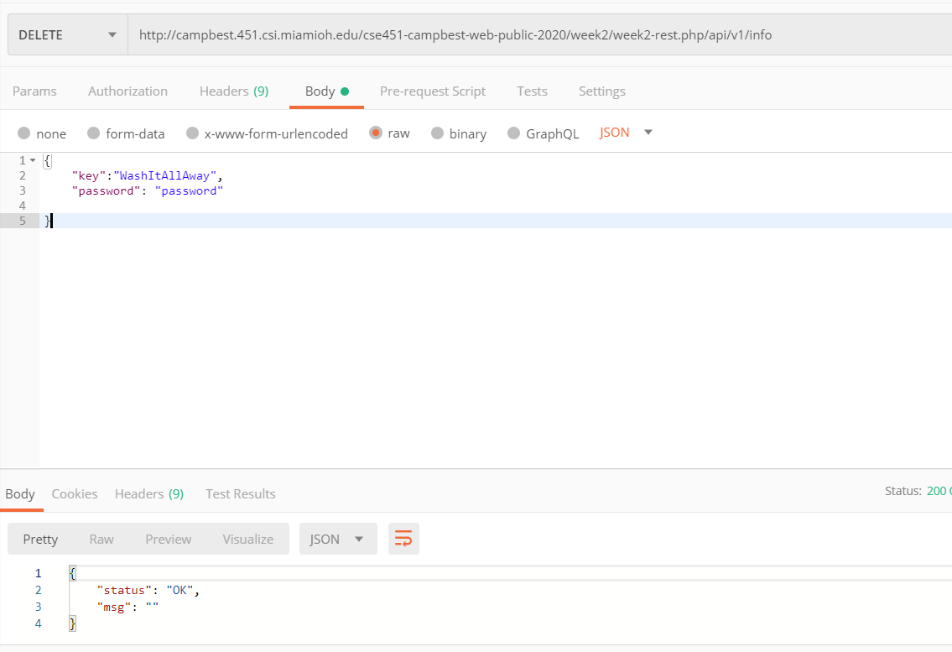

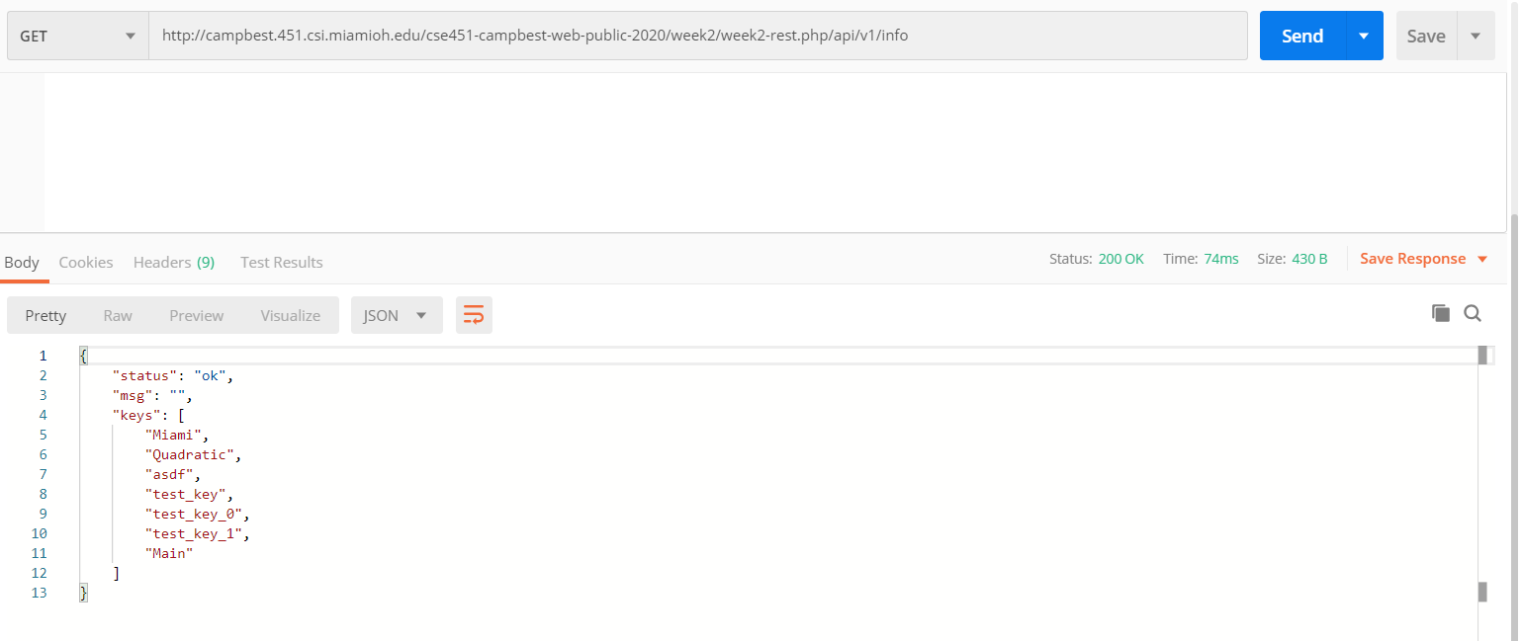

5.

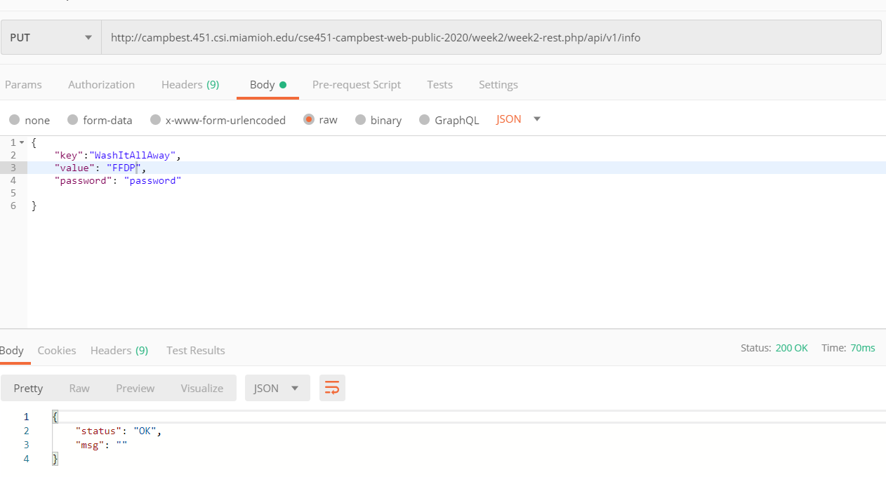

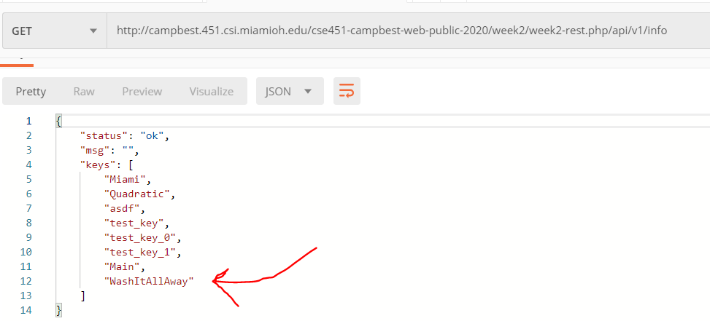

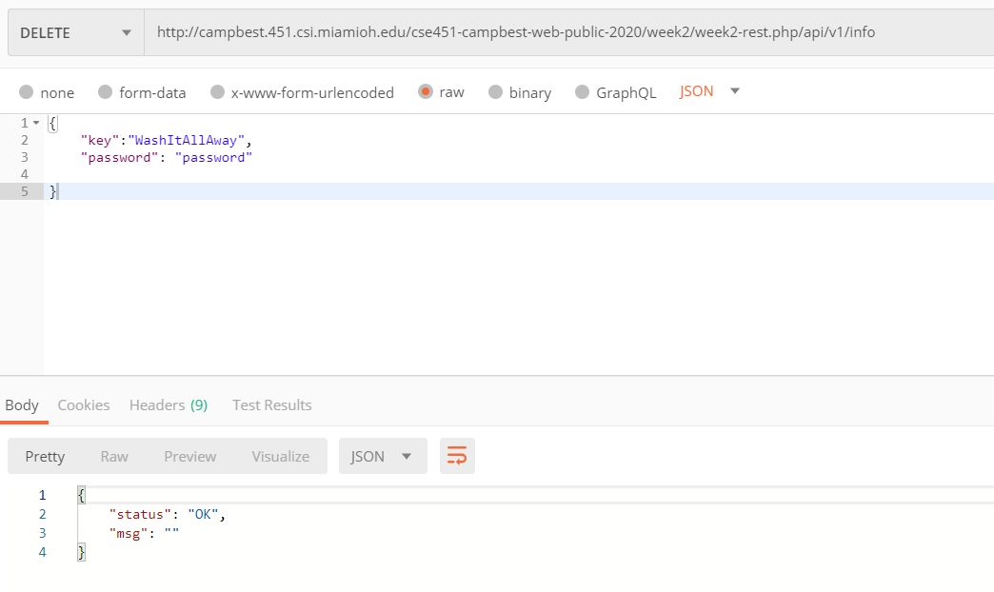

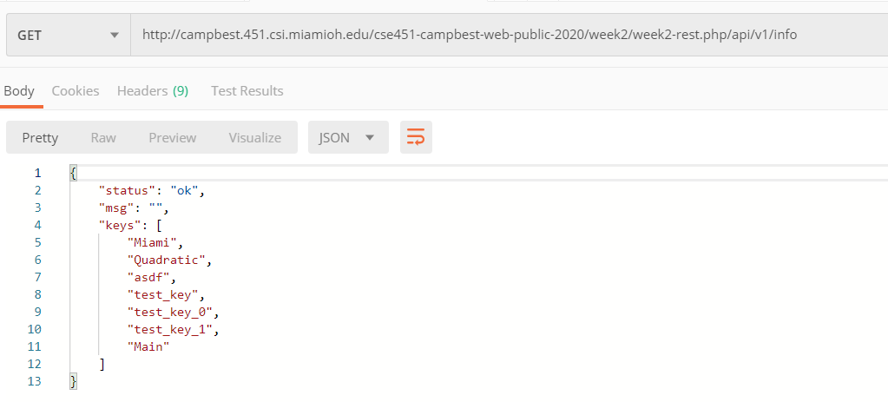

6. Nothing

7. 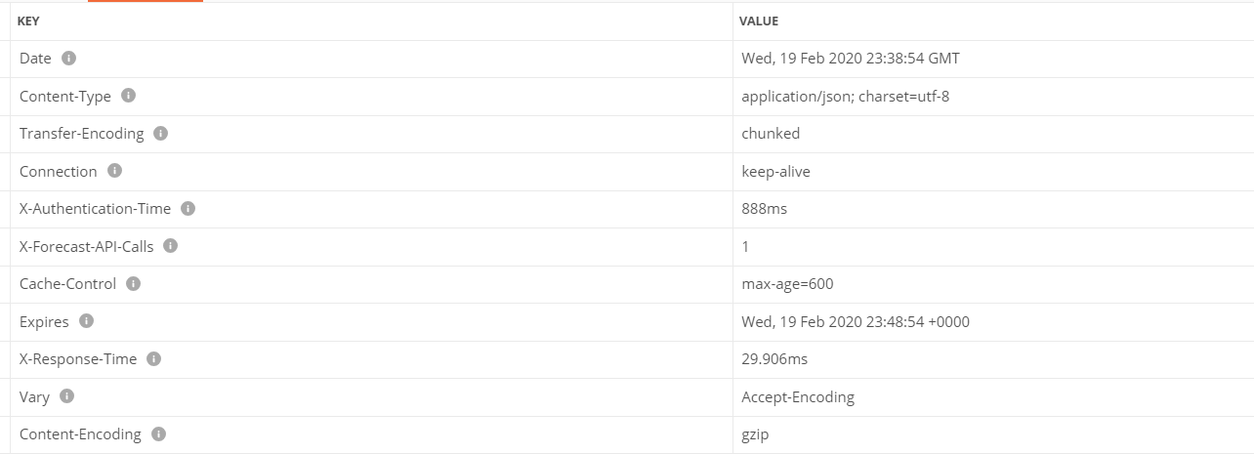

**Date:** Date and Time of when the request was issued

**Content-Type:** The response is encoded in string type UTF-8 in the form of a JSON object

**Transfer-Encoding:** The object was sent in the chunked encoding format

**Connection:** The connection will sustain after the completion of the request

**X-Authentication-Time:** A custom header that saves the amount of time it took the API to authenticate the request

**X-Forecast-API-Calls**: A custom header that determines the number of calls made from the account

**Cache-Control:** A header that controls how long we will cache data from the API request

**Expires:** Determines when a request becomes “stale” or not up to date any longer

**X-Response-Time:** A custom header for how long it took to process the request and send back a response

**Vary:** Determine how to match future request headers to the current request in order to see if cached or fresh data needs to be used.

**Content-Encoding:** How the entirety of the body is encoded

8.

https://api.darksky.net/forecast/SECRET_API_KEY/39.5070,-84.7452,2020-01-01T00:00:00

**Temperature:** 32.83

**Humidity:** 0.76

**Wind-Speed:** 12.14

**Wind-Gust:** 23.85

9. Putting your API key out for the world to see enables anyone to call the REST server on your behalf at any time they once. Although we do not have billing information currently set up on this website, if it were set up, anyone could create a client to generate hundreds of thousands of REST calls and rack up a massive bill on your behalf. Keeping your API keys secret is just another layer to provide some insurance.